1. **IP subnet tables.**

|  |  |  |  |  |
| --- | --- | --- | --- | --- |
| **VM Subnet** | **IP Subnet** | **Network** | **Range** | **Broadcast** |
| R2(eth1), R3(eth0) | 10.10.11.0/30 | 10.10.11.0 | 10.10.11.0-10.10.11.3 | 10.10.11.3 |
| R2(eth2), R4(eth1) | 10.10.11.4/30 | 10.10.11.4 | 10.10.11.4-10.10.11.7 | 10.10.11.7 |
| R3(eth1), R4(eth0) | 10.10.11.8/30 | 10.10.11.8 | 10.10.11.8-10.10.11.11 | 10.10.11.11 |
| R4(eth2) | 10.10.11.12/28 | 10.10.11.12 | 10.10.11.12-10.10.11.27 | 10.10.11.27 |

1. **Copies of the conf files under /etc/frr/frr.conf for each of R2, R3 and R4.**

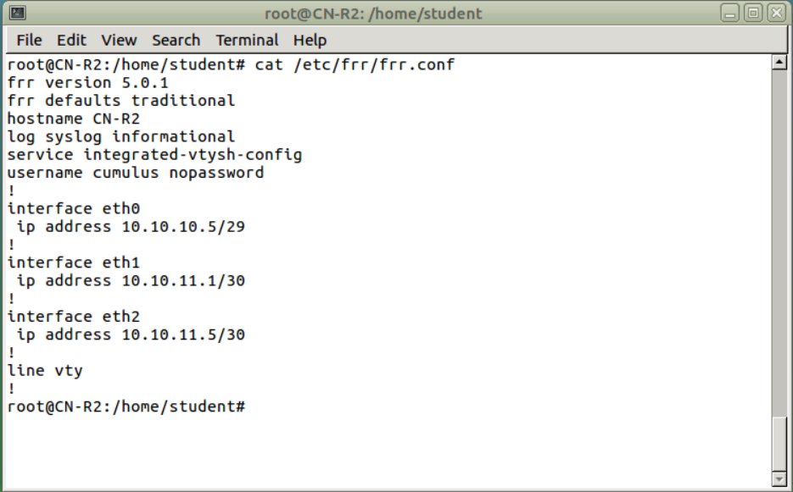

Capture 1 Config Files for R2

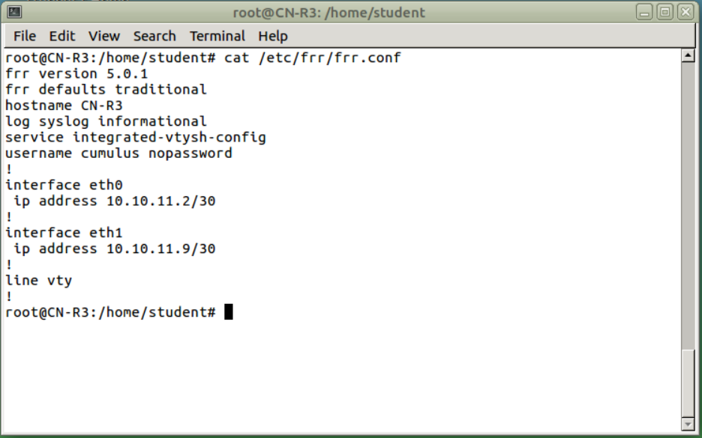

Capture 2 Config File for R3

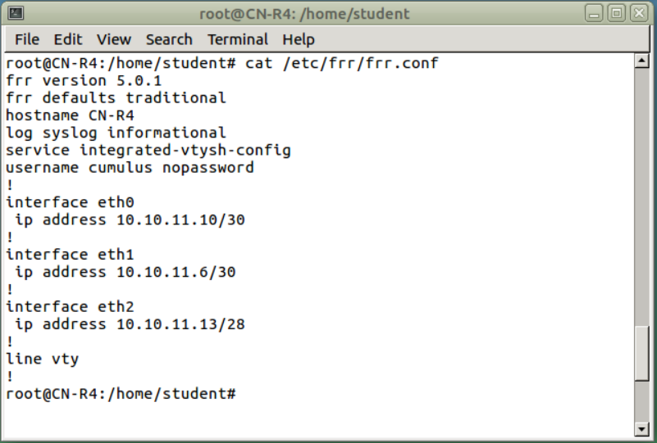

Capture Config File for R4

1. **The Ethernet addresses of R2, R3 and R4.**

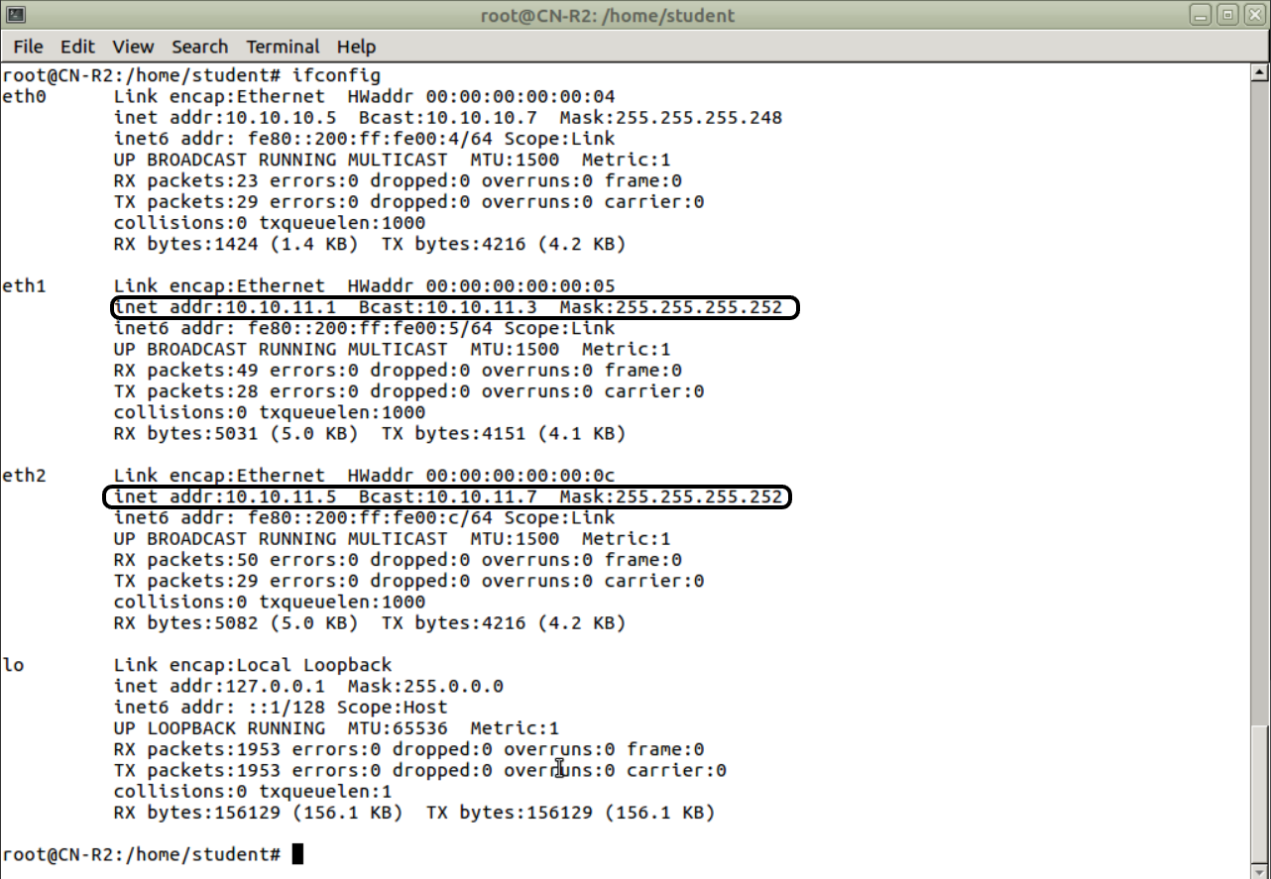

Capture Ethernet Address R2

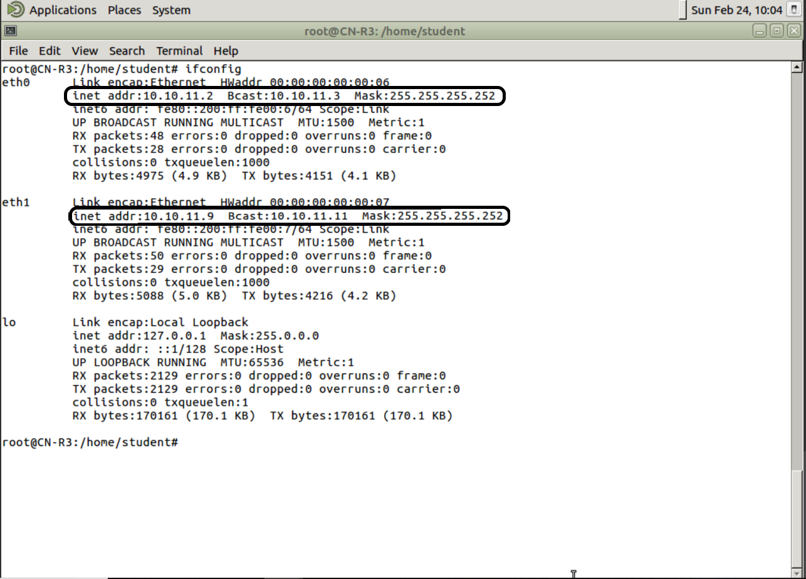

Capture Ethernet Address R3

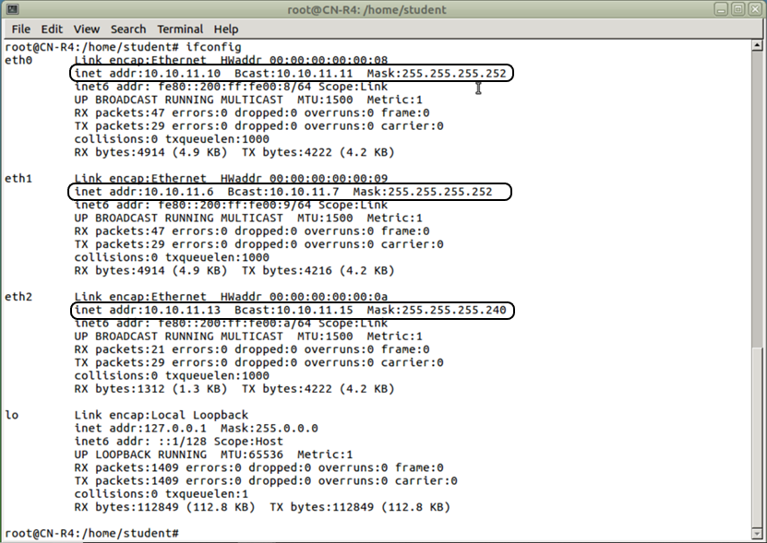

Capture 6 Ethernet Address R4

1. **Pinging between R2, R3 and R4.**

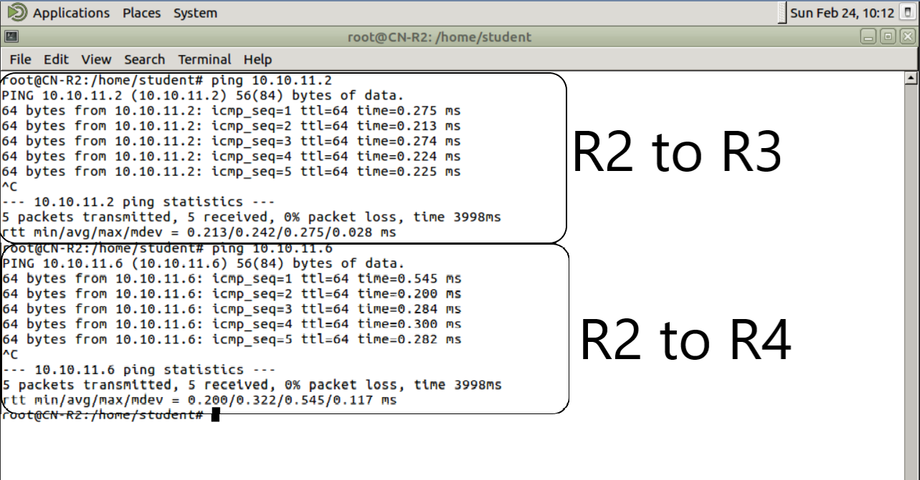

Capture Ping R2 to R3, R4

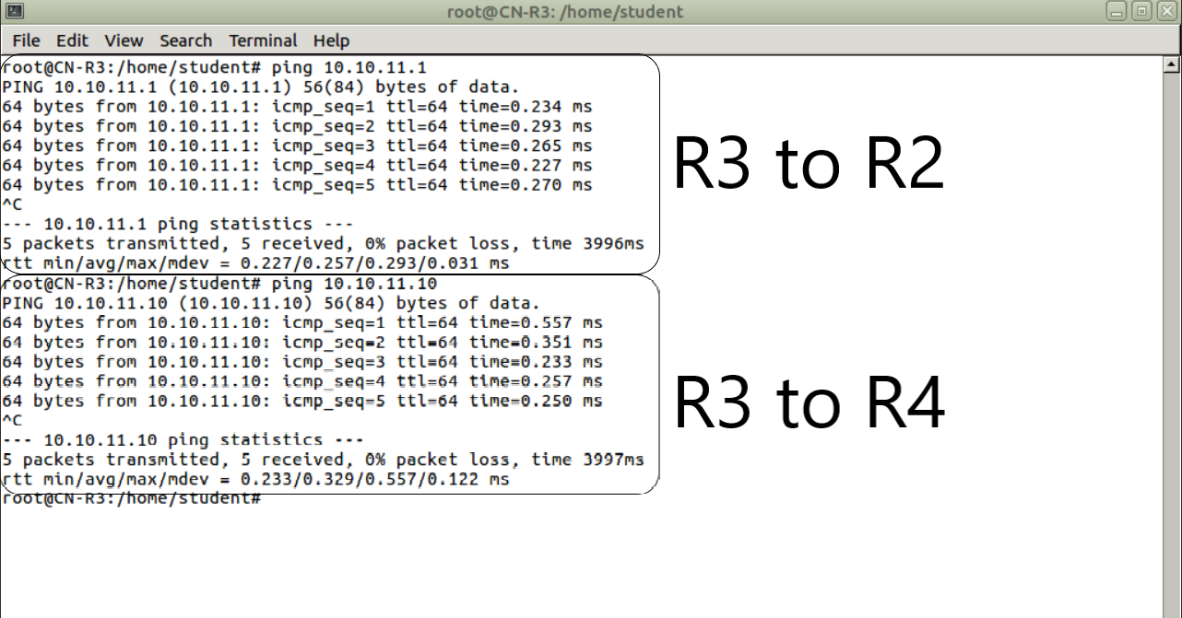

Capture Ping R3 to R2, R4

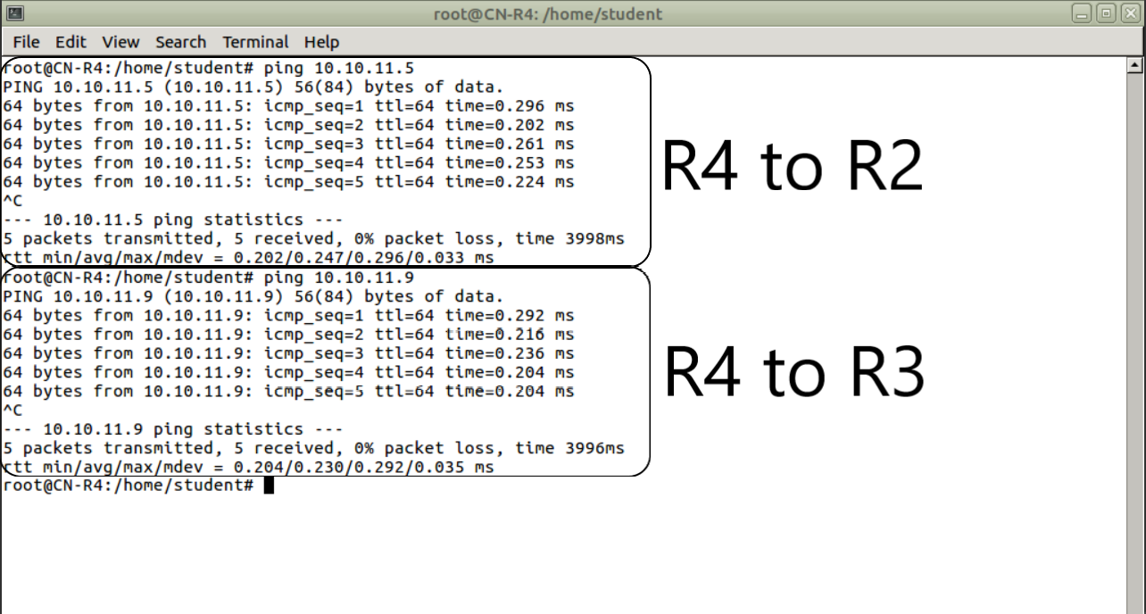

Capture Ping R4 to R2, R3

1. **Copies of the ARP tables on R2, R3 and R4.**

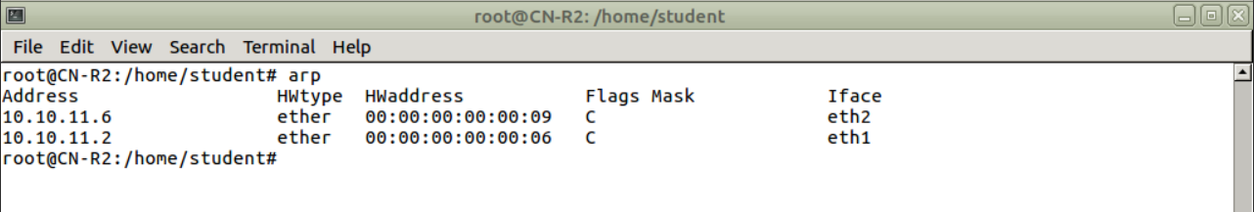

Capture ARP Table R2

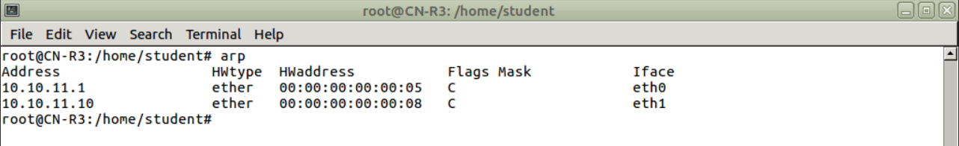

Capture ARP Table R3

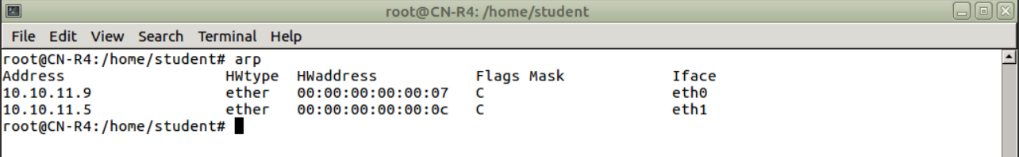

Capture ARP Table R4